

**MANUAL B2B PORTAL**

**Contents:**

1. **Login to your account**
2. **Adding articles to your basket**
3. **Finalizing your order**
4. **Overview of orders, deliveries and invoices**
5. **Contact**
6. **Login to your account**

Go to b2b.pighen.com. Enter your email address in the login field and your password in the password field and click “ENTER“.

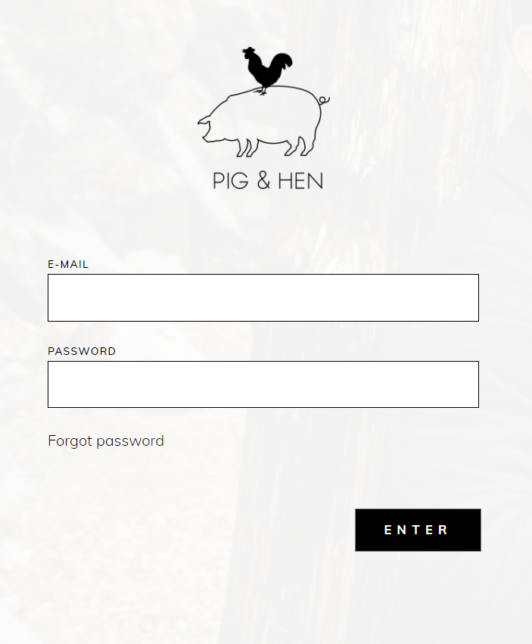

If you do not know your password, you can recover your password. Click on “FORGOT PASSWORD”.

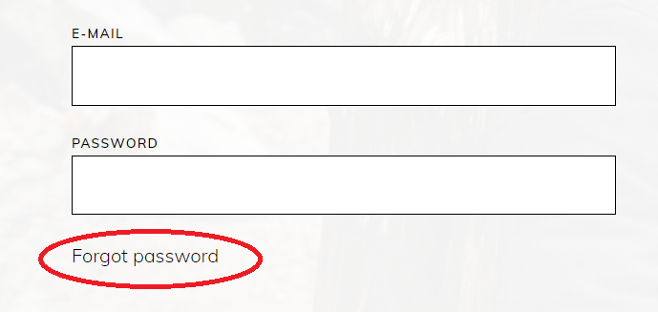

Enter your email address and press “RESET”’ and follow the instructions you receive in your mail. The link in the mail to reset your password is only valid for 24 hrs.

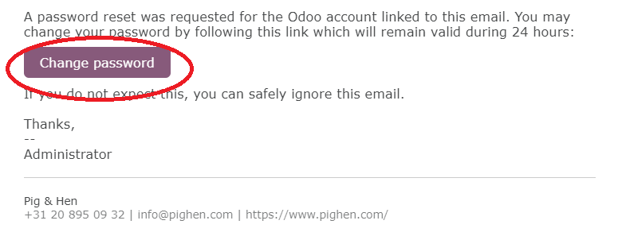

If you do not know which email address you used for your B2B Account, then contact us by phone or mail.

1. **Adding articles to your basket**

When you are logged in, you can add articles to your basket. By default you will see all our products. You can use the navigation to select specific bracelet types, POS material, shackles or season. Alternatively you can use the search icon on the upper right hand corner.

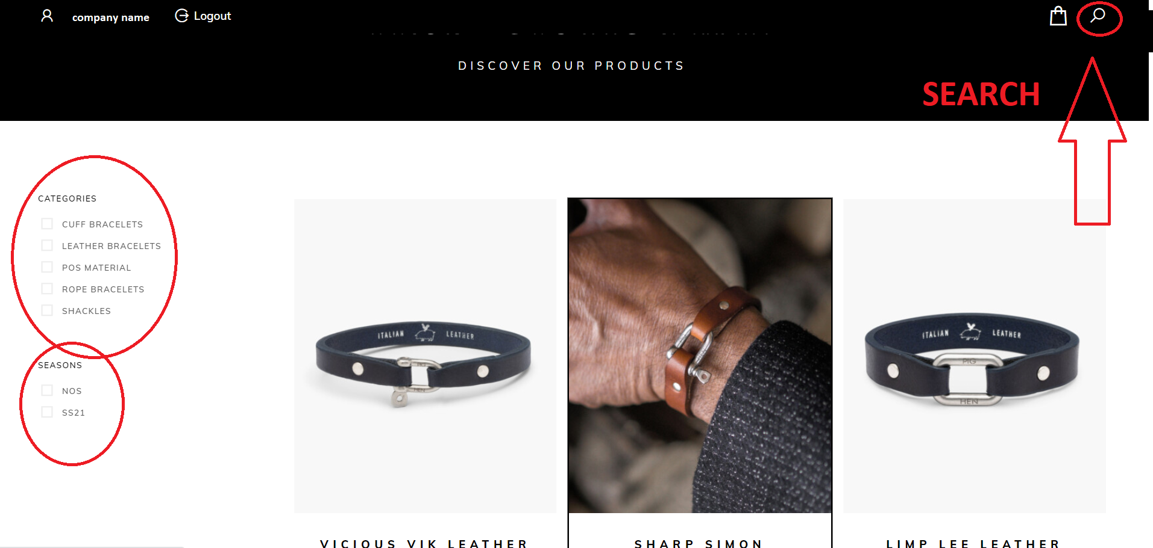

When you select a bracelet type, you see all available colours and sizes. Simply click on “+” to add a size to your basket.

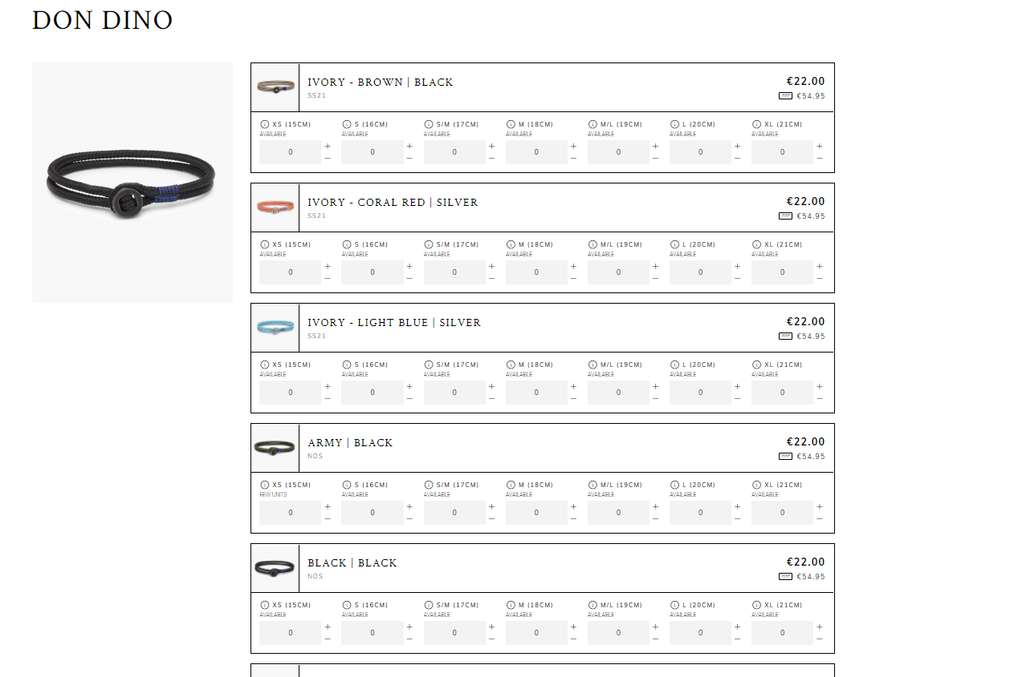

When you are done for this bracelet type, click “ADD TO BASKET”.

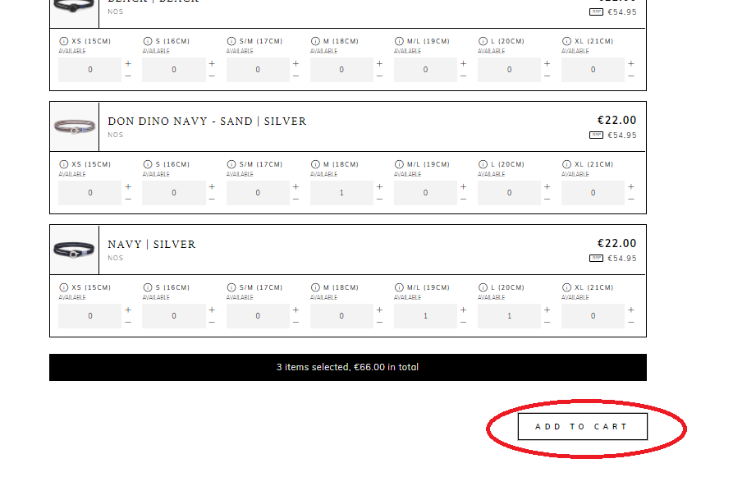

Continue these steps for other bracelets, POS Material or shackles.

1. **Finalizing your order**

When you have put all articles in your basket, you can proceed to check out. Press the shopping bag icon to go to your shopping bag.

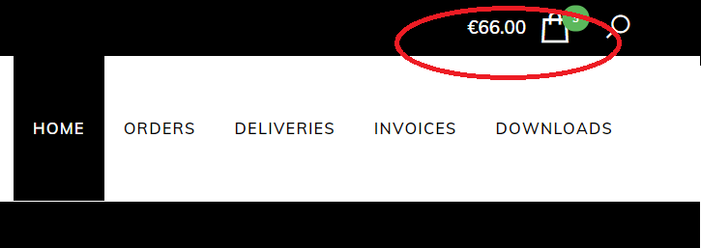

You will now see an overview of all the items in your shopping bag. Press the green Check-out button to check-out. You will now see the ‘Order information’ page. At this page you can enter your PO-number and add remarks. If you have several delivery addresses, you also have to select your delivery address here. Press the green “FINALIZE ORDER” button to send your order. Now your order has been sent. Thank you!

1. **Overview of orders, deliveries and invoices**

In your B2B environment you have an overview of the orders you placed, deliveries and invoices. Simply click on the caterogy you would like to see.

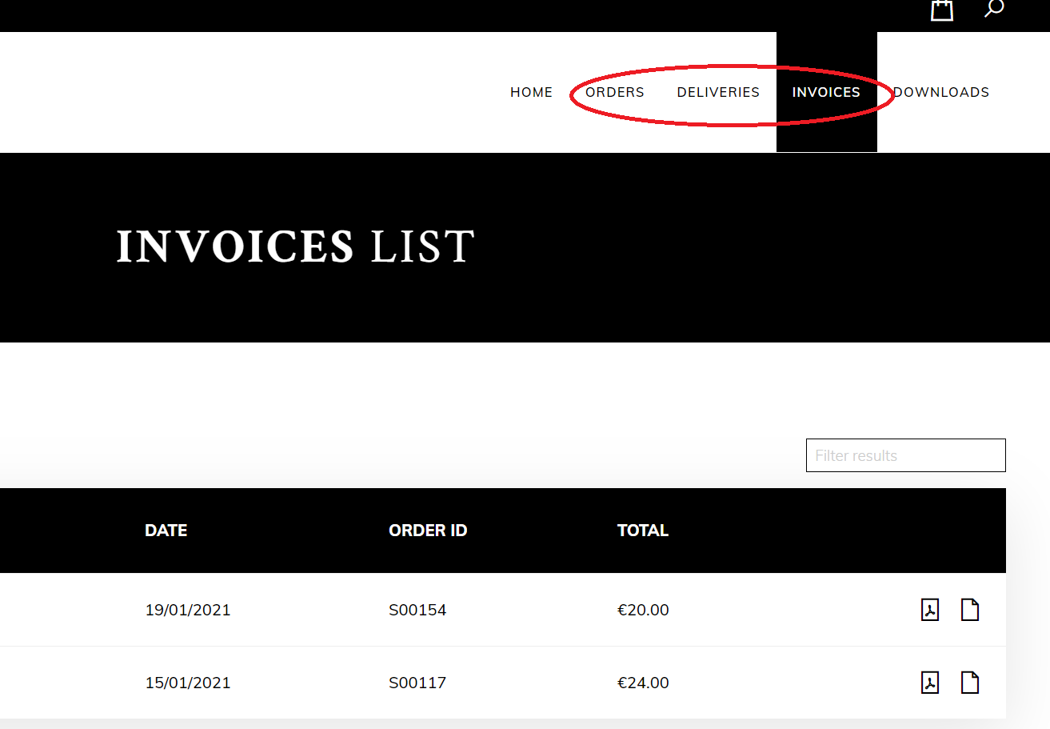

You can see the orders, deliveries and invoices in the B2B environment. If you wish to download them click on the PDF logo. In a new browser window the PDF will appear.

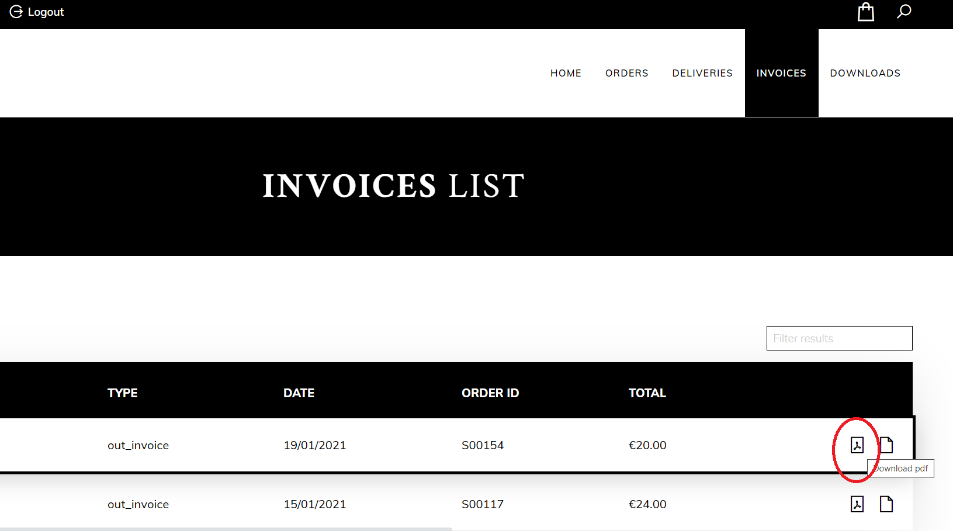

1. **Contact**

If you have any questions or difficulties using the B2B environment, do not hesitate to contact us by phone on +31 20 8950932 or by mail: [info@pighen.com](mailto:info@pighen.com). We are there to help you.